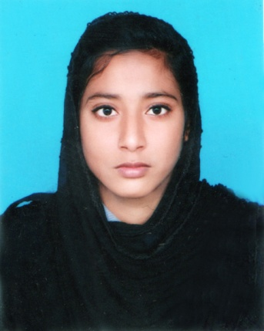
Curriculum Vitae

Most. Akhi Aktar
C/O : Md. Abdul Aziz
Contact no. : +8801723-270171
E-Mail : avayaakhi@gmail.com

Career Objective
I am looking for a hard and challenging job where I will have the scope to utilize my knowledge and skills for the development of the institution. I believe I will perform any task honestly as my goal.
Academic Qualification
- Diploma In Engineering (Mechanical)
Name of Institution : Rangpur Polytechnic Institute, Rangpur.
Department : Mechanical
Result : CGPA 3.55 in the scale of 4.00
Passing Year : 2021
- Secondary School Certificate (S.S.C)

Name of Institution : Mulatol Girl’s High School, Rangpur.
Board : Dinajpur
Group : Science
Result : GPA 4.36 in the scale of 5.00
Passing Year : 2017
Computer Knowledge
- Operational System : Windows XP, Windows 7
- Database Languages : MS Office.

Language Skills
- Bengali : Mother Tongue
- English : Reading, Writing and Speaking fluently.

Strength
- Patient, honesty and positivism.
- Creative thinking, dedication and hard working.
- Self motivated and strong concern for career.
- Good leadership skill.

Personal Information
- Name : Most. Akhi Aktar
- Father’s Name : Md. Abdul Aziz
- Mother’s Name : Most. Mukta Begum
- Permanent Address : House No- 256, Road No-05, Mulatol P.O. Rangpur
P.S : Kotwali, Dist : Rangpur.
- Present Address : Vill: Goneshpur Bakultola P.O. Babukha
P.S : Kotwali, Dist : Rangpur.
- Date of Birth : 19th May 2001
- Sex : Female
- Nationality : Bangladeshi (By birth)
- Blood Group : A+^{(ve)}
- Height : 5 feet 3 inch.
- Marital Status : Unmarried
- Religion : Islam
- National ID No : 1032178087

Training
- Welding Training 04 Month from SEIP.
- Office Application, Internet Browsing, Email,

Declaration
I thereby, declare that the above information in the resume is true and correct to the best of my knowledge and behalf.

Signature:

………..……….............…
Most. Akhi Aktar
Date :

