Sabrina Tamanna
E-1,Eastern Housing
Pallabi 2nd Phase , Mirpur,
Dhaka-1216.
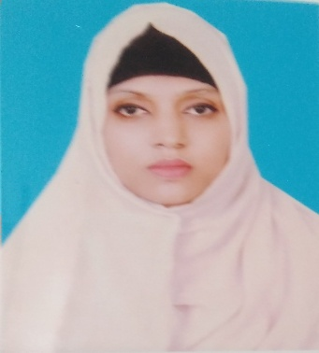

Contact
Phone : +8801712185391
+8801682437750
E-mail : sabrinaakhi90@gmail.com

Profile
Objective : | I aspire for a career that would provide me abundant opportunities for continued growth and achievements. A career where my analytical skills, ideas, ability, creativity, education and communication skill are extremely utilized in a way that, my contribution to the organization helps it to get better.

Academic Background
MA Institute : Govt. Bangla College
Subject : English (Literature)
Passing Year : 2013
Result : 2nd Class
University : National University
B.A Hon’s Institute : Govt. Bangla College
Subject : English (Literature)
Passing Year : 2012
Result : 2nd Class
University : National University
Higher Secondary Certificate (H.S.C) Institute : Mirpur Girls` Ideal Laboratory Institute
Major : Humanities
Passing Year : 2008
Result : 4.20
Board : Dhaka
Secondary School Certificate (S.S.C) Institute : Pallabi M.I. Model high school
Major : Humanities
Passing Year : 2006
Result : 3.63
Board : Dhaka

Key Skills
Computer | Operating System : Windows 7, Windows 8 & Windows 10  Office tools : MS-WORD, MS-Excel  Networking : LAN, WAN
Language | Bangla - Mother Tongue.  English - Fluent both in speaking & writing.

Interests
Traveling Cox’s Bazar, Sylhet, Teknaf and other historical places in Bangladesh.
Technology To know about new technology, computer networking.

Personal Information
Father's Name : Md. Shahjahan
Mother's Name : Asma Begum
Date of Birth : 7th July 1990
Nationality : Bangladeshi
Religion : Islam
Marital Status : Married
NID NO : 2804832414
Permanent Address : E-1, Eastern Housing , Pallabi 2nd Phase , Mirpur,
Dhaka-1216

Declaration
I am the undersigned, hereby declare that the above information is true and I will be

Responsible for any wrong information.

 17/08/2022
Sabrina Tamanna Date:

